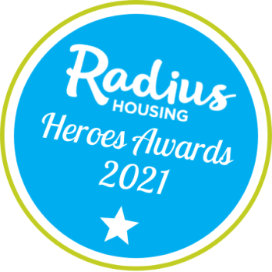
Radius Heroes Awards
Nominate 2021
Nominee Name:
Address/Scheme:
Category Please state the category you wish to enter…
Best Kept Garden / Community Pride / Healthy Living & Learning / Good Neighbour Award / Creativity Award / Lockdown Legend

Tell us about the nominee (no more than 300 words)
FOR OFFICE USE ONLY /20

Supporting Information
You may send up to 5 photos,videos, posters etc. to support your application. If you have attached any supporting information please note below:
We will try our best to return any printed photos, please ensure the return name/address is noted on the back.
Tell us about you:
Name:
Address:
Email:
Phone:
Thank you for submitting your nomination for the Radius Awards 2021.
Deadline for nominations is Friday, 4 June 2021

Did you know you can also enter online at https://tinyurl.com/RadH21

Please post your completed entry to: Scheme Awards, Communities Holywood, Radius Housing Association, FREEPOST BEL4018, Holywood, BT18 9BR or
email tenant.engagement@radiushousing,org.

